CHEMICAL REACTIONS

BEHAVIOUR OBJECTIVES
At the end of this lesson, students should be able to;
- write balanced equations of reactions.
- explain the meaning of chemical equations.
- explicate the collision theory.
- enumerate and give 5 examples of chemical reactions.
- explicate at least 5 factors affecting rates of chemical reactions.
- calculate rates of chemical reactions.

A chemical reaction is a process where a set of substances undergo chemical change to form a new substance. Reactants and products are the substances used to bring about chemical reaction. A reactant is the substance consumed or used up during the reaction while product is the substance produced by a chemical reaction. To describe the initial reactants and the end products, chemical equation is written.

CHEMICAL EQUATIONS are representations of chemical reactions in terms of the symbols and formulae of the elements and compounds involved.
In a chemical equation, the reactants are written first, on the left, followed by an arrow pointing to the products written on the right-hand-side of the arrow.
A + B → C + D
Reactants Products
NB: an unbalanced equation is of little value. It should therefore be balanced. Here, the total number of atoms of any element on the left-hand side must be equal to the total number of atoms of that element on the right-hand side.

KEY POINT:
- Equations must be balanced through the use of co-efficient in front of the formulae and not by changing the subscript number with the formulae.
- Take into consideration atoms that exist as diatomic, triatomic.
- Simple chemical equation is balanced by trial and error.

- H₂ + O₂ → H₂O Unbalanced
H₂ + O₂ → H₂O₂ BALANCED BUT WRONG
2H₂ + O₂ → 2H₂O Balanced

- Fe + H₂O → Fe₃O₄ + H₂ Unbalanced
3Fe + 4H₂O → Fe₃O₄ + 4H₂ Balanced

RATES OF REACTIONS
Rate of chemical reaction is the number of moles of reactant converted or products formed per unit time.
Mathematically;
For a reaction in solution;
Rate = $\frac{\text{Change in concentration}}{\text{Time taken}}$
For a reaction in solid state (reactant or product);
Rate = $\frac{\text{Change in mass}}{\text{Time taken}}$
For a reaction in gaseous state;
Rate = $\frac{\text{Change in volume}}{\text{Time taken}}$

COLLISION THEORY
It assumes that for a chemical reaction to occur, the reacting particles must collide with one another.
Not every collision between reactant particles results in a reaction, only a small fraction does, successive collision is called Effective Collision.
For a reaction to occur, the reacting particles must possess a certain minimum amount of energy called Activation Energy.
Activation energy is minimum amount of energy colliding reactants particles must possess for a reaction to occur.
Activation energy can be likened to an energy barrier, which must be overcome before a reaction can occur. So, any collision that does not possess that certain amount of energy will not proceed. Every reaction has its own activation energy. A reaction with low activation energy will take place spontaneously at room temperature while that with high activation energy will only take place if heat is applied.

THE REACTION PROFILE

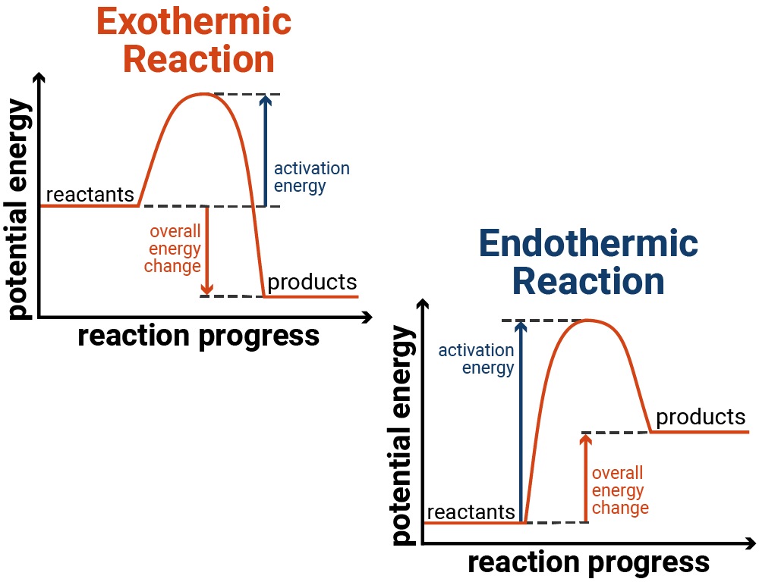

TYPES OF CHEMICAL REACTIONS
- Combination or Addition Reaction: when two or more elements or compounds combine to form a single compound.
A + B → C
Fe_{(s)} + S_{(s)} → FeS_{(s)}
NH_{3(g)} + HCl_{(g)} → NH₄Cl_{(s)}

- Decomposition Reaction: when one reactant breaks down into two or more products. When heat is required, it is known as Thermal Decomposition.
C → A + B
2HgO_{(s)} → 2Hg_{(l)} + O_{2(g)}
2AgNO_{3(s)} $\underset{→}{ ∆ }$ 2Ag_{(s)} + O_{2(g)} + 2NO_{2(g)}

- Displacement Reaction: the replacement of one element (or radical) by another element (or radical) in a compound. It is between an element and a compound.
A + BC → B + AC
Zn_{(s)} + CuSO_{4(aq)} → ZnSO_{4(aq)} + Cu_{(s)}
Br_{2(g)} + KI_{(aq)} → 2KBr_{(aq)} + I₂
A more electropositive metal will displace a less electropositive metal WHILE a more electronegative non-metal will displace a less electronegative non-metal.

- Double Decomposition Reaction: when two compounds react to produce two new compounds by exchange of ions.
AB + CD → AD + CB
AgNO_{3(aq)} +NaCl_{(aq)} → AgCl_{(s)} + NaNO_{3(aq)}
H₂SO_{4(aq)} + CuO_{(s)} → CuSO_{4(aq)} + H₂O_{(l)}
The two reactants are soluble while one of the products is soluble and the other is insoluble, volatile or gaseous.

- Reversible Reaction: a reaction which can be made to proceed in either direction under suitable conditions.
A + B ⇄ C + D
3Fe_{(s)} + 4H₂O_{(g)} → Fe₃O_{4(s)} + 4H_{2(g)} (action of steam on red-hot iron)
CaCO_{3(s)} + H₂O_{(l)} + CO_{2(g)} → Ca(HCO₃)_{2(aq)}

- Thermal Dissociation Reaction: involves the dissociation of a compound into two or more smaller molecules or atoms when heat is applied.
NH₄Cl_{(s)} ⇄ NH₃ + HCl
N₂O_{4(g)} ⇄ 2NO_{2(g)}

- Catalytic Reaction: A reaction which uses a catalyst. The rate of reaction is altered by a catalyst (positive or negative).
2SO_{2(g)} + O_{2(g)} $\underset{→}{ {\text{NO}}_{\left(\text{g}\right)} }$ 2SO_{3(g)} (Homogeneous Catalysis)
N_{2(g)} + I_{2(g)} $\underset{→}{ {\text{Fe}}_{\left(\text{s}\right) }}$ 2NH_{3(g)} (Heterogeneous catalysis)

FACTORS AFFECTING RATES OF REACTIONS
- Nature of reactants: the nature of the reactants taking part in the reaction affects the rate of reaction. e.g. hydrogen with combine with chlorine vigorously under certain conditions while it will only react with nitrogen slightly.

- Concentration of reactants: it is directly proportional to the rate of reaction. Increase in concentration will increase in rate of reaction and vice versa.

- Pressure for gases: directly proportional. If the pressure is elevated, the rate of reaction will increase.

- Effect of temperature: rate of chemical reactions increases when the temperature is raised. It is generally observed that a temperature rise of 10ºC doubles the rate of reaction.

- Surface area of reactants: the greater the surface area of the reactant, the higher the rate of reaction(solid). e.g. a reaction with one gram of iron fillings will be faster than with one gram of iron nail.

- Presence of catalyst: a catalyst is a substance that alters the rate of reaction, but itself does not undergo any change at the end of the reaction. A positive catalyst (promoter) increases the rate of reaction by lowering the activation energy whereas, a negative catalyst (inhibitor) slows down the rate of reaction by increasing the activation energy.

- Presence of light: some reactions are influenced by light. The rate of reaction is high when the intensity of light is high, low when the intensity of light is low and does not proceed at all in the absence of light. Such reactions are known as photochemical reactions. e.g. photosynthesis of plant, reaction between hydrogen and chlorine.

CALCULATIONS
- In the reaction:
H_{2(g)} + I_{2(g)} → 2HI_{(g)}
If the concentration of HI increases from 0 to 0.001 moldm⁻³ in 50 seconds, what is the rate of reaction?

Change in concentration = 0.001 – 0 = 0.001moldm⁻³, Time = 50 seconds
Rate = $\frac{\text{Change in concentration}}{\text{Time taken}}$
Rate = $\frac{0.001}{50}=2 × {10}^{-5} mol{dm}^{-3}s^{-1}$

- Marble chips weighing 4.0g were dropped into a large volume of hydrochloric acid, 2.5g of the marble remained after 5 minutes. Calculate the rate of reaction?

mass of reactant = 4.0g, mass of product = 2.5g,
time taken = 5mins = 5 $×$ 60 = 300 seconds
Rate = $\frac{\text{Change in mass}}{\text{Time taken}}$
Rate = $\frac{4.0-2.5}{300}=5 × {10}^{-3} gs^{-1}$

DRILL QUESTIONS
- The rate of reaction usually decreases with a decrease in the concentration of reactants because _______?
- Speed increase
- Kinetic energy decreases
- Reactants collision deceases
- Temperature increase

- Which of the following factors does not affect the rate of reaction for non- gaseous reactants?
- Pressure
- Temperature
- Concentration
- Surface area

- Major difference between thermal dissociation and thermal decomposition is that _______?
- Thermal dissociation is reversible
- Thermal decomposition is reversible
- Thermal decomposition is not reversible
- Thermal dissociation is not reversible

- Positive catalyst in chemical reactions
- Improve stability of reactants
- Improve the speed of chemical reactions
- Improve stability of products
- Improve the efficiency of a catalyst

- Which of the following negatively affects the rate of reaction?
- Concentration of reactants
- Pressure for gases
- Temperature
- None of the above

ANSWER
- C
- A
- A
- B
- D

